How to Add/Edit Sponsor Logos

Step 1.
- Go to touchingheart.com/admin/
- username: Helen.Yi password: Helen2012
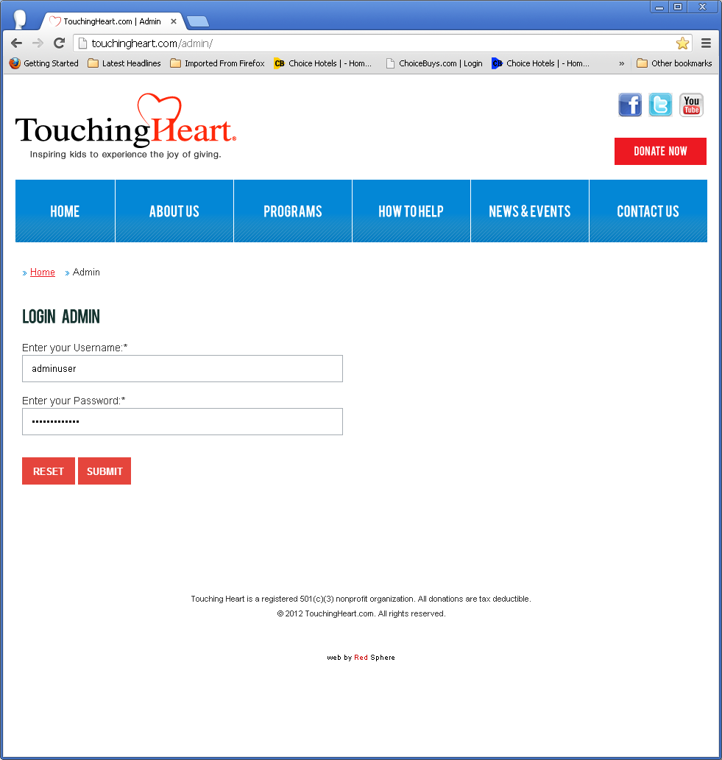

Step 2.
once you are logged in, scroll down and navigate to the page you are going to edit, in this case the golf event:
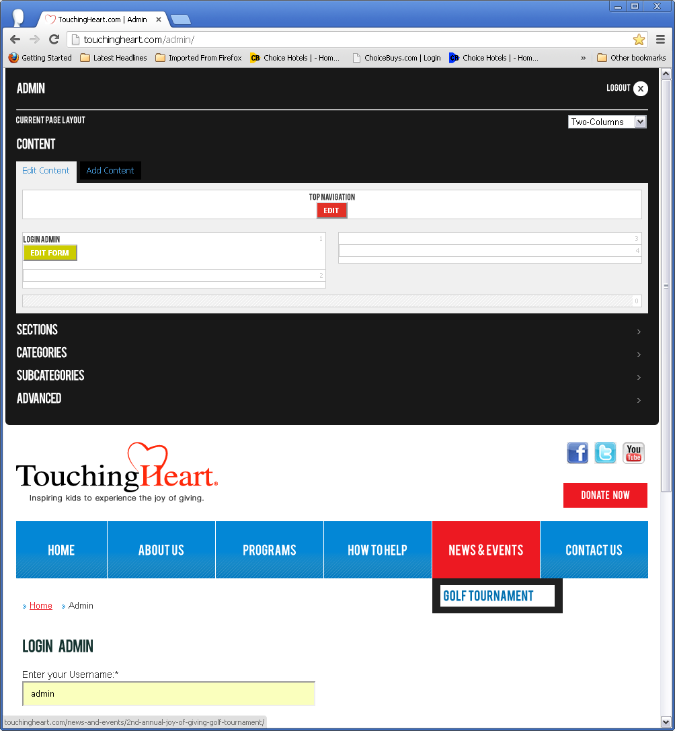

Step 3.

Edit
To Edit a Sponsor Album, press the respective button “edit gallery”. Instruction continues below the image:
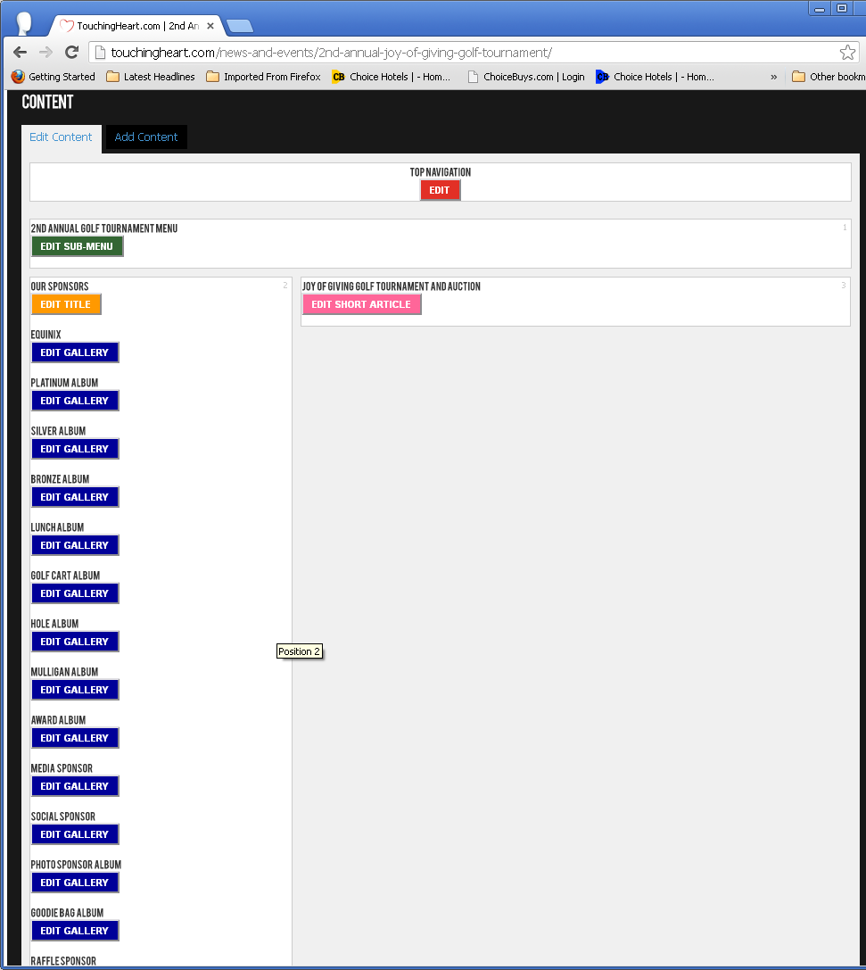

The administration accepts png or jpg. Any other format needs to be converted first. Just drag and drop the image in the black box.
About the Short description, please note that the format to enter the information is as follow:
Sponsor Name.<br/>- Sponsor category -;
if there are more than one (1) sponsor, then the format is as below (separated by comma):
Sponsor Name.<br/>- Sponsor category -;, Sponsor Name 2 .<br/>- Sponsor category 2 -;
Once everything is in order press save.
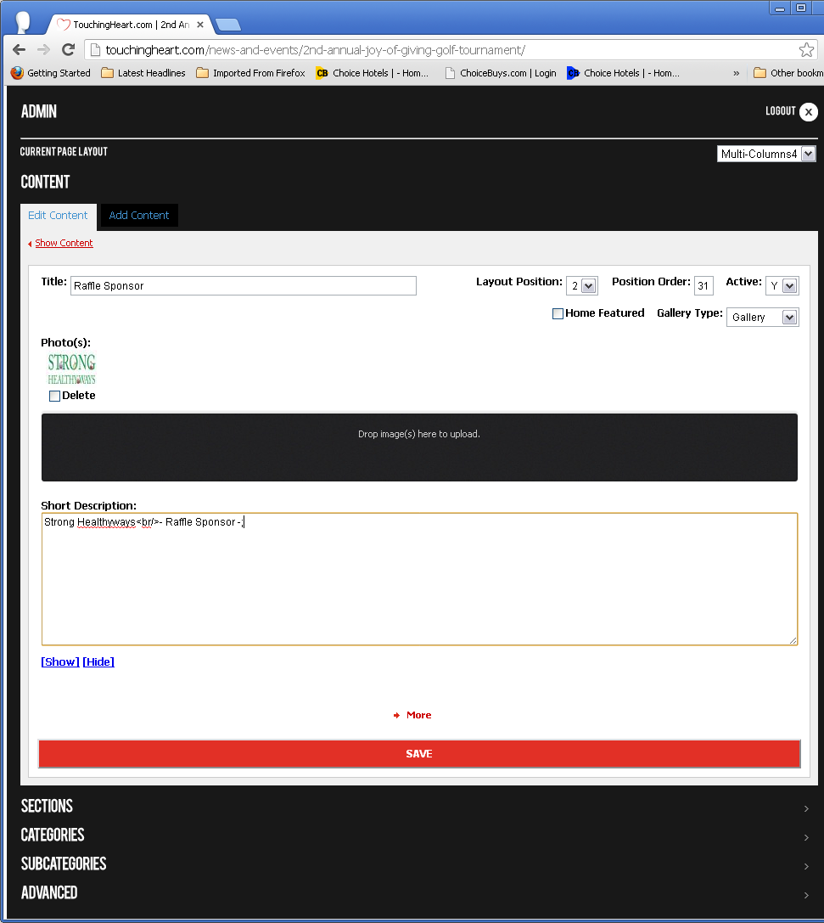

Add
To add a Sponsor Album, press the “Add Content” button located in the content admin section, and then click on “Gallery – Photo Album”. Instruction continues below image:
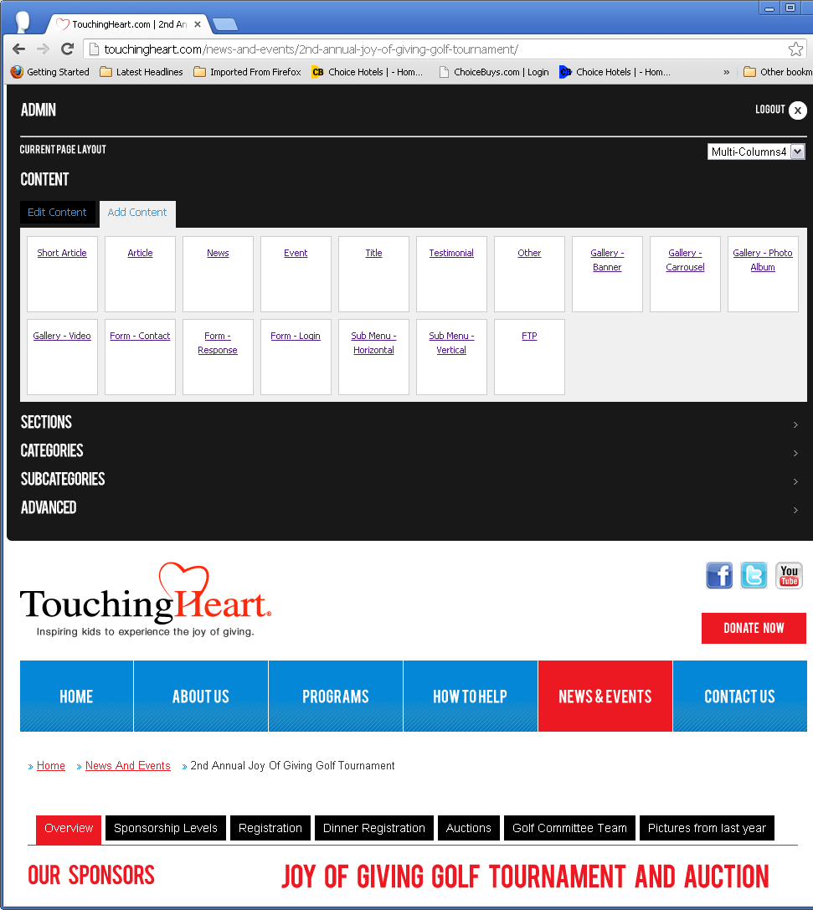

Complete all the information as follow:
Title: Name of the album.
Layout Position: This is the position of the album in the page. In this case is position #2.
Position Order: The albums load according to the position you enter here. We have from 0 (Equinix), to 14 (raffle). If you need to add some album in between you have to change the order in other albums as well.
The administration accepts png or jpg. Any other format needs to be converted first. Just drag and drop the image in the black box.
About the Short description, please note that the format to enter the information is as follow:
Sponsor Name.<br/>- Sponsor category -;
if there are more than one (1) sponsor, then the format is as below (separated by comma):
Sponsor Name.<br/>- Sponsor category -;, Sponsor Name 2 .<br/>- Sponsor category 2 -;
Once everything is in order press save.
